**Creating Current Account Action**

Create a new action skill Current, for the current account action.

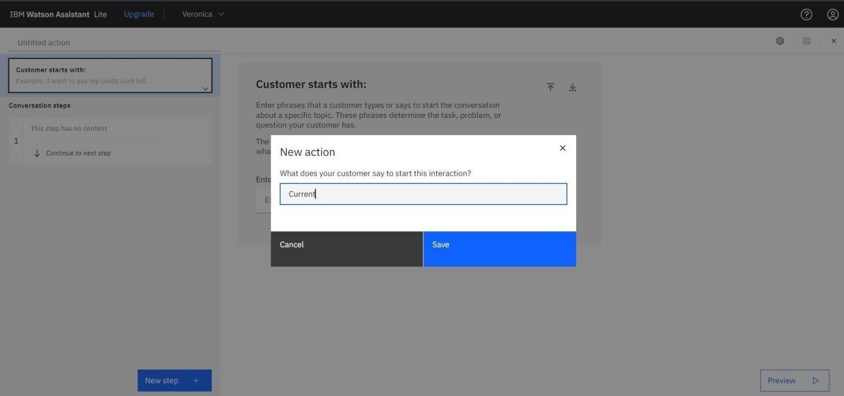

.

Adding steps in Current action to handle customer queries regarding Partnership and Proprietorship account creation

